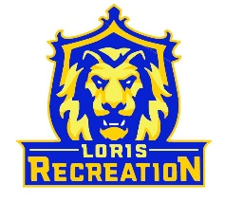
8U Brown Baseball
Schedule
Coach: Ryan Brown
Date Opponent Location_______________
Saturday 4/15 @ 11:30am at 8U Norris Field 3
Monday 4/17 @ 6:00pm vs 8U Alford Field 1
Thursday 4/20 @ 6:00pm vs 8U Miller Field 1
Monday 4/24 @ 7:15pm at Green Sea Floyds 2 Green Sea Recreation
Tuesday 4/25 @ 6:00pm vs 8U Norris Field 1 *PICTURE DAY*
Monday 5/1 @ 7:15pm at 8U Miller Field 1
Tuesday 5/2 @ 6:00pm vs Pee Dee Field 1
Thursday 5/4 @ 7:15pm at 8U Alford Field 1
Monday 5/15 @ 7:15pm at Aynor Aynor Recreation
Thursday 5/18 @ 6:00pm vs Green Sea Floyds 1 Field 1

NOTES:
-For Picture Day, your picture time will be given closer to the actual date. You will have pictures taken in the Rec Office at that time and all the ordering information will be sent to you via your email on file. There is NO pre-ordering, it is all done online through the link that is sent to you
-Concession Stand will be open for ALL home games
*Aynor 1253 Vereen Road Conway, SC
*Green Sea 5050 Tulip Grove Nichols, SC

