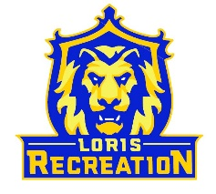
8U Basketball Team Mishoe
Schedule
Coach: John Mishoe

Date Opponent Location_______________
Saturday 1/28 @ 11:00am (G) at Aynor #3 Aynor HS Mini Gym
Saturday 2/4 @ 9:00am (G) at 8U Rich Loris High School
Tuesday 2/7 @ 7:15pm (G) at 8U Ford Loris High School
Saturday 2/11 @ 9:00am (B) vs 8U Rich Loris High School
Tuesday 2/14 @ 6:15pm (B) vs 8U Ford Loris High School
Saturday 2/18 @ TBD Post-Season Tournament Loris High School

(B) = wear Blue Jerseys
(G) = wear Gold Jerseys

*Aynor High School 201 Jordanville Road Aynor, SC

