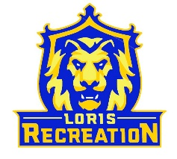
8U Basketball Team Ford
Schedule
Coach: Junior Ford

Date Opponent Location_______________
Thursday 1/26 @ 6:15pm (B) vs 8U Rich Loris High School
Saturday 1/28 @ 10:00am (G) at Aynor #2 Aynor HS Mini Gym
Tuesday 2/7 @ 6:15pm (G) at 8U Rich Loris High School
Tuesday 2/7 @ 7:15pm (B) vs 8U Mishoe Loris High School
Tuesday 2/14 @ 6:15pm (G) at 8U Mishoe Loris High School
Saturday 2/18 @ TBD Post-Season Tournament Loris High School

(B) = wear Blue Jerseys
(G) = wear Gold Jerseys

*Aynor High School 201 Jordanville Road Aynor, SC

